How to Make a Donkey Model
*This art sheet works best when printed on card
What you will need:
Colouring pencils or crayons
Scissors
2 wooden cloths pegs
Glue
Wool

Instructions:
- First colour in the body to match the colour of your favourite Blackberry donkey.
- Then carefully cut around the body. You may need an adult to help you.
- Now colour the wooden pegs to match the body.
- Next cut a piece of wool and glue it onto the body, to make the donkey’s tail.
- Finally separate the wool on the end of the tail to make a tassel. Now your donkey is complete.
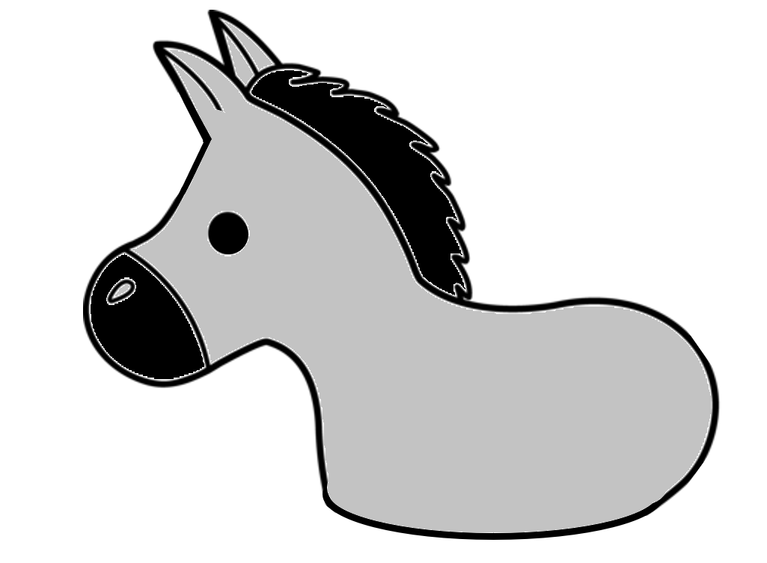
Glue the tail on here
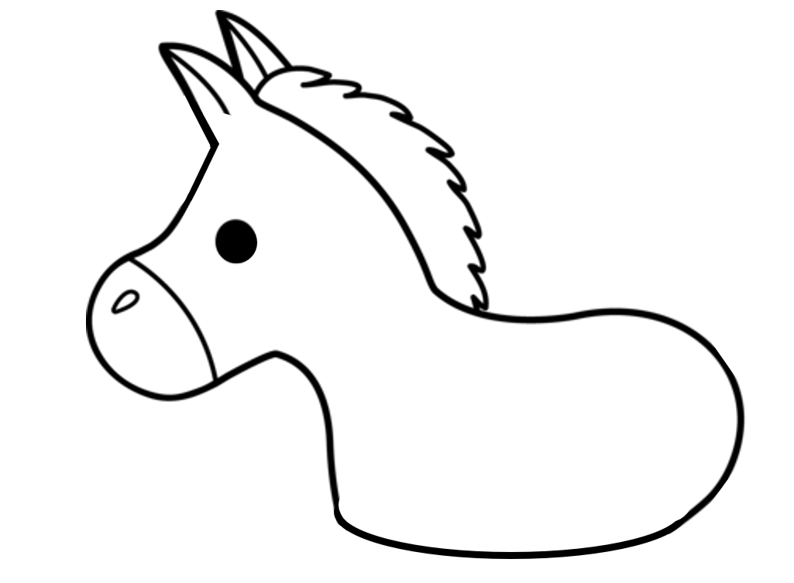
Clip wooden cloths pegs on here

