Look at the photograph of Joseph the donkey. Now label the parts of the body.

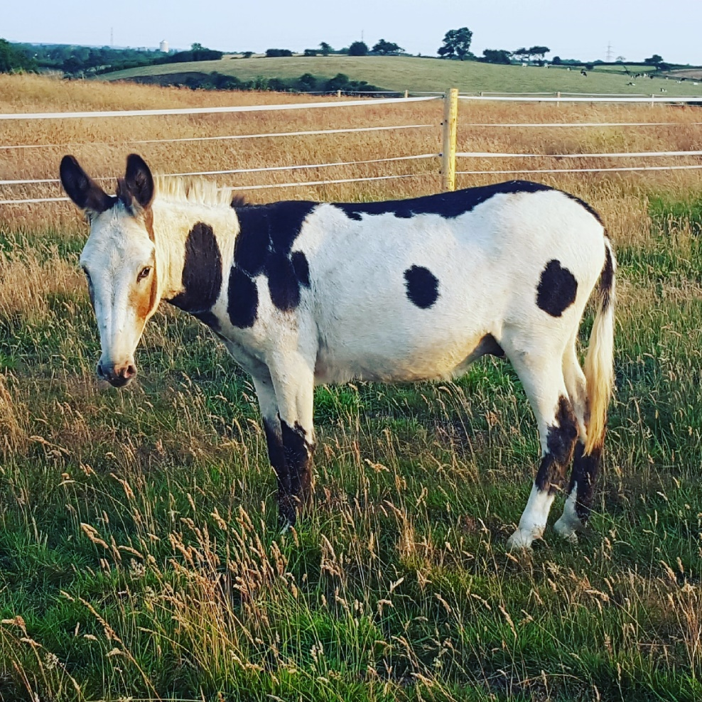
mane muzzle withers hoof

